**Research methods and approaches to primary and secondary research**

**Introduction -**

This report based on the presentation will compare the statistical data from my primary and secondary research data which are collected from questionnaires in the form of google forms. From recent research and draw conclusions based on the strength and weaknesses of the topic regarding “Are technology companies responsible for the health, safety and wellbeing of users?” In addition, I will elaborate more on the impact on how it affected the health and safety of users and the future of society.

**Research used in this research -**

This report will cover the types of research methods that are used in conducting a research with the help of different methods.

**Primary Research :**

This research method involves first hand collection of data by an individual for analysis, study, research, or documentation of the collected information.

**Questionnaire** - This research involved getting data through questionnaires that were designed to get the customer's consent and approval to gather data form them for the purpose of the research. This type of research is done by an individual with specific questions relating to a topic of interest. This information is collected to further develop in the future and give a wider range of view to a specific topic.

**Google Forms** - These are data forms which are collected from groups of people about a certain issue that bothers or might have issues with, and discuss a satisfying solution to resolve the issue.These are data forms which are collected from groups of people about a certain issue that bothers or might have issues with, and satisfying solutions to resolve.

**Secondary Research :**

This research method involves second hand collection of data by an individual for analysis, study, research, or documentation of the collected information.

**Data available online -**

These are data that are available online that can be used to support the research. Data gathered from different resources that are proven by experts and professionals in the field. This is one of the most popular forms of research methods. It is free to use in some cases or may be charged some amount to use the data.

**Public libraries -**

This is the most convenient of research that is used to gather data for research which are filled with hundreds of books with research articles, documentations, journals, newspapers that are preserved from the past to be analysed. They also have huge collections of selections from different publishers and authors for the public to use.

**Commercial information sources -**

These are commercial outlets that include newspapers, journals, magazines, radio and T.V stations are great resources and for reviews. Commercial information are data that are collected recently which may consist of marketing research, demographic segmentations political agenda and can be used in documentation, economic development

**Quantitative Research**-

This type of research is based on data that is collected in general which is from a specific region or area which allows to indicate how different regions reflect upon a specific data.

**Qualitative Research-**

This type of research is done to identify the reason and motivation for a problem and offers ideas to the problem with hypotheses to predict the outcome and following trends of the data.

**Mixture Research-**

This type of research involves both Quantitative and Qualitative researches that include collecting, research, analysing data that have been collected with a better understanding of the research problem which are Quantitative or Qualitative.

**Research Methodologies used -**

**Ontology -**

It is a broader study of concepts which are based on reality and beliefs that is based on general knowledge which is real and not based on studies and researches that have been done by experts and professionals.

**Epistemology -**

It is based on theoretical knowledge which has been proven with extensive research and analysed thoroughly through documentation and historical data that have been proven with evidence supporting theories and knowledge with research data, statistics, analysis, evaluations and philosophies to come to a conclusion.

**Graphs and Charts -**

The data gathered for primary and secondary will be presented in the form of charts and graphs which will be compared side by side to show how they would be in terms of local verses compared to the rest of the world. This will demonstrate digital wellbeing with a more clear perspective to explore their function in a wider view.

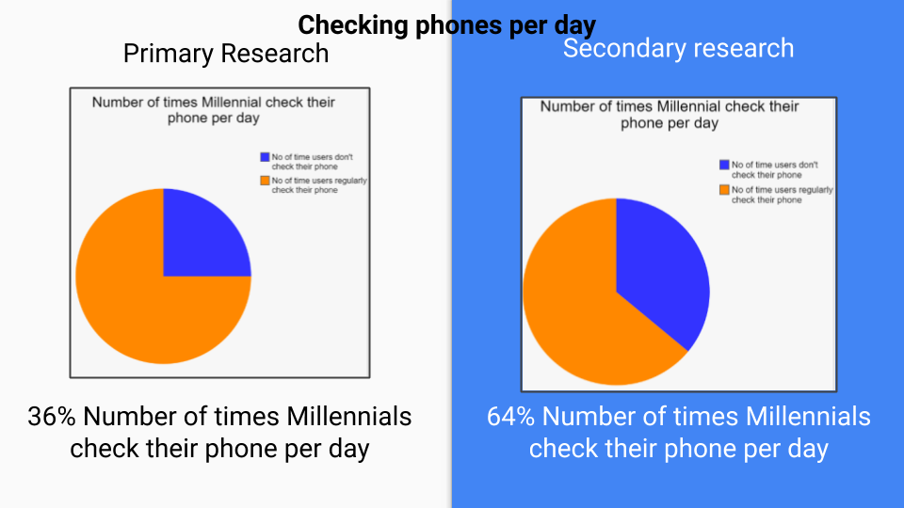

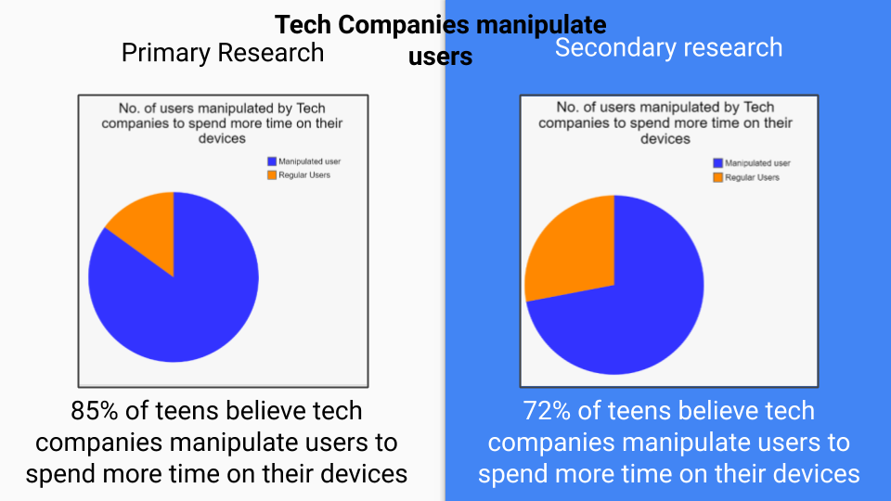

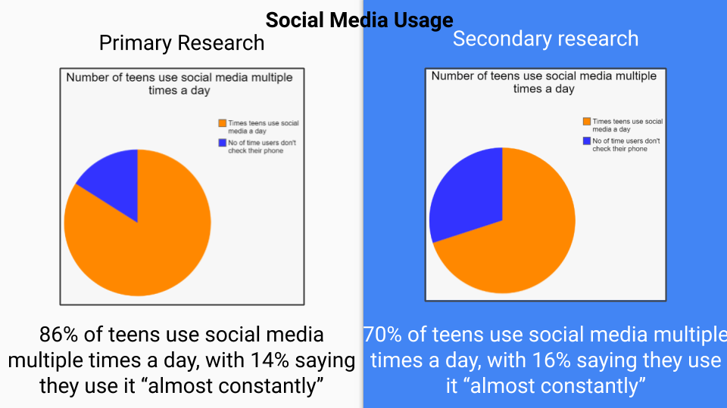

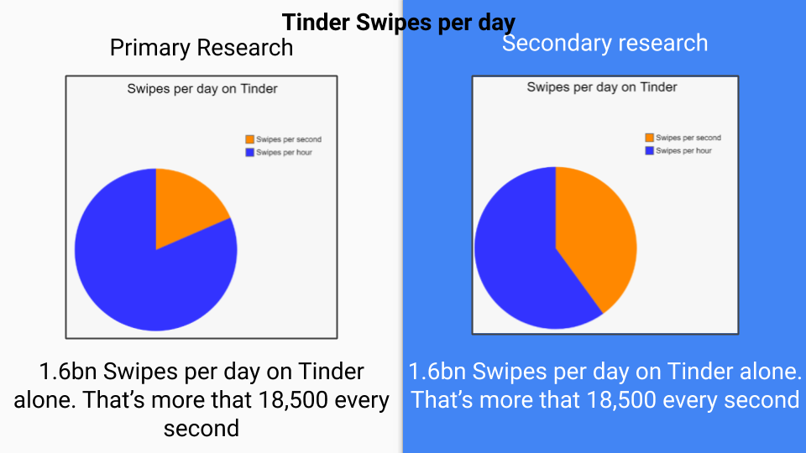

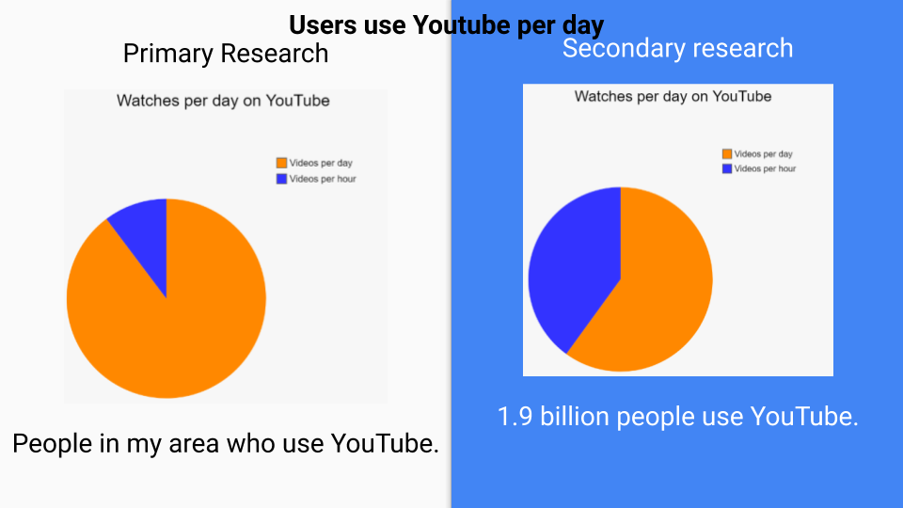

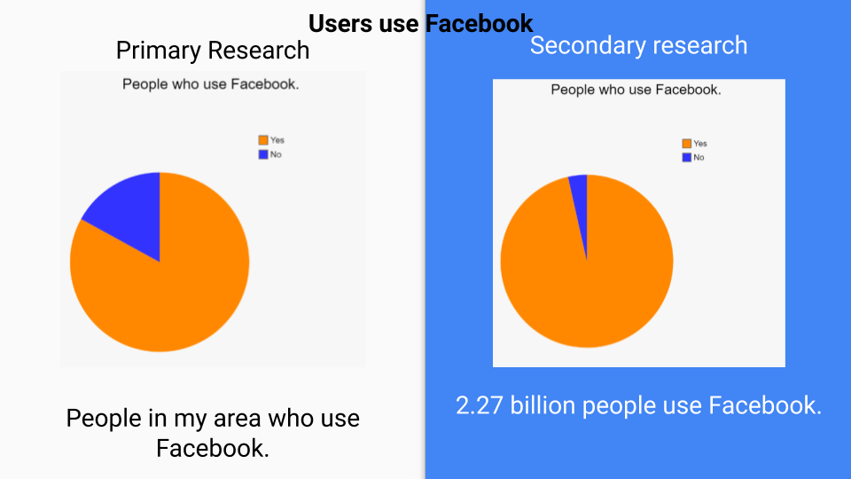

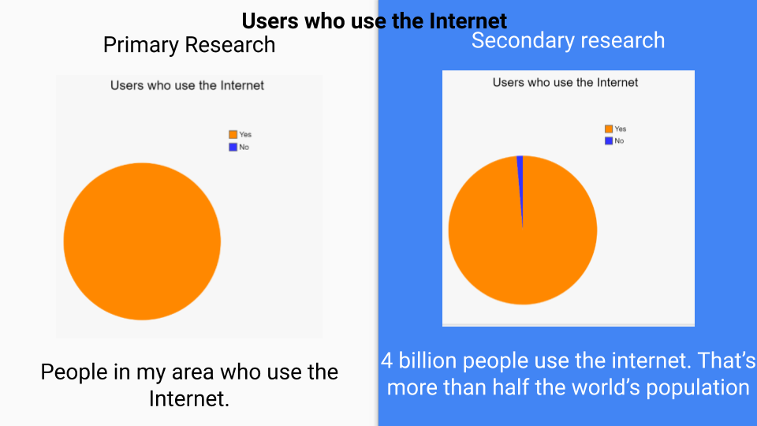

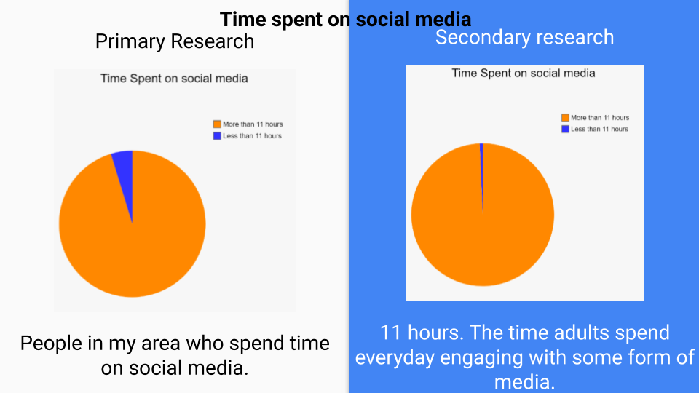

**Recommendations**

* The recommendation I would give based on the above primary and secondary research performed would be that digital wellbeing is growing more and more as users spend more time on their devices and seek for help to stay in control of their health.
* Users should stay in control by implementing strict rules to follow to reduce the amount they spend on devices and find other things to distract them from their addictions and find new hobbies that they like.
* Taking a break would greatly improve their lifestyle and motivate them to go outside and make meaningful relationships and conversations which would otherwise not be possible.
* Users must take the first step in making a change in their daily habits by joining groups that move away from digital distractions and find other ways to interact with people.

**Conclusion -**

In conclusion, this report will examine appropriate research methods and approaches to primary and secondary research using appropriate tools and techniques and approaches as part of the research process. It involves further steps in collecting resources and data that can be used to perform analysis based on the environmental situations.

It also compared the statistical data from my primary and secondary research data which are collected from questionnaires in the form of google forms. From recent researches and drawing conclusions based on the strength and weaknesses of the topic regarding “Are technology companies responsible for the health, safety and wellbeing of users?” In addition, I also elaborated more on the impact on how it affected the health and safety of users and the future of society.